- Student ID: 240031810
- Name: S. LALITH ADITYA
- Experiment Number: 11
- Section Number: 22

SKILL-11: React API Integration - Fetching Data Using Fetch API, Axios & Local JSON Project Structure.
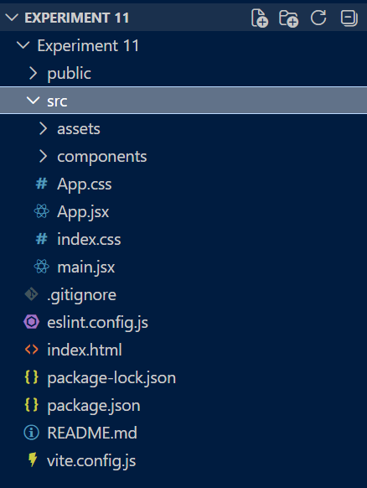

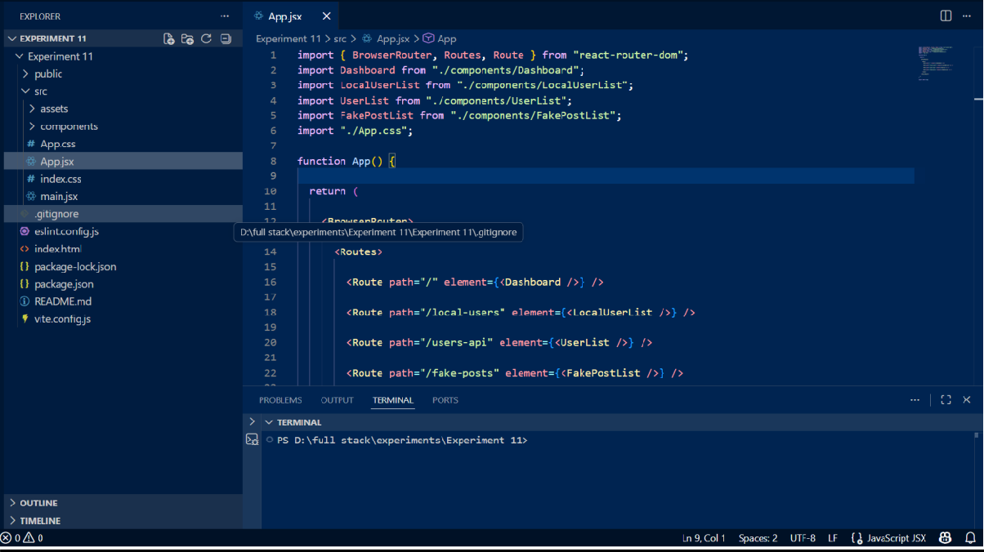
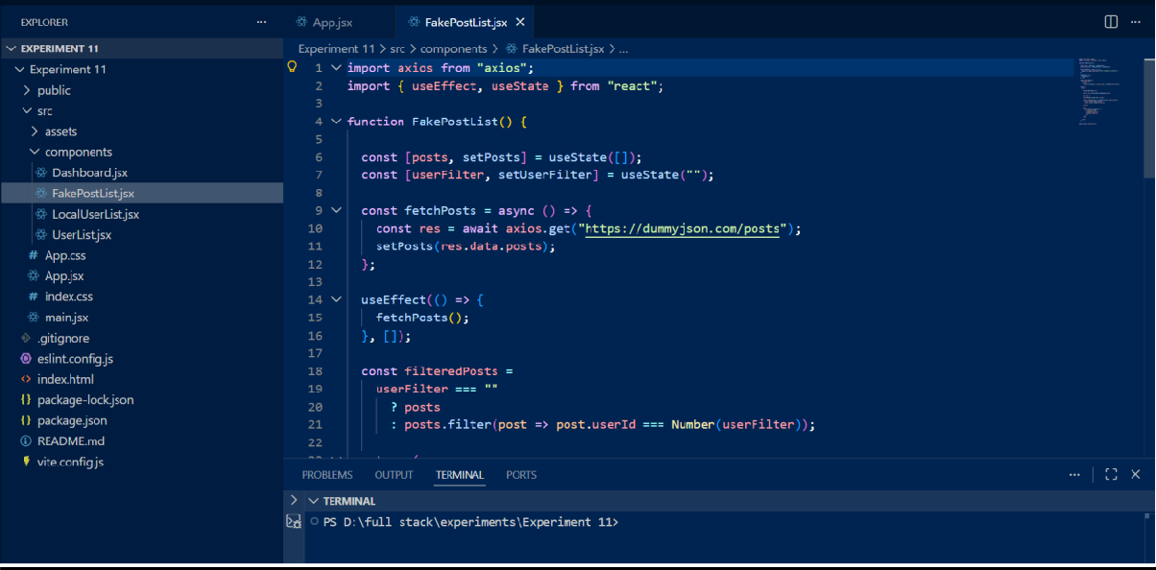
FakePostList.jsx

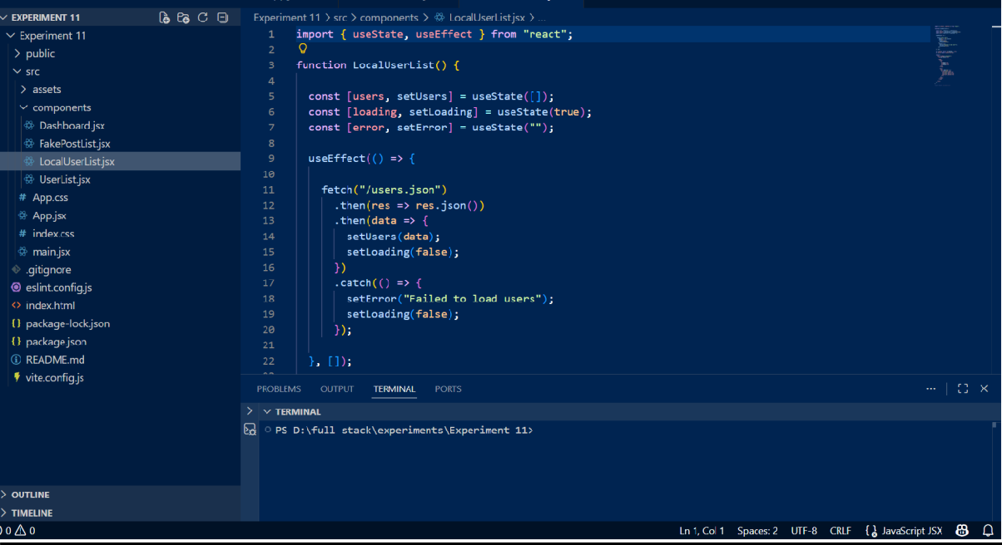
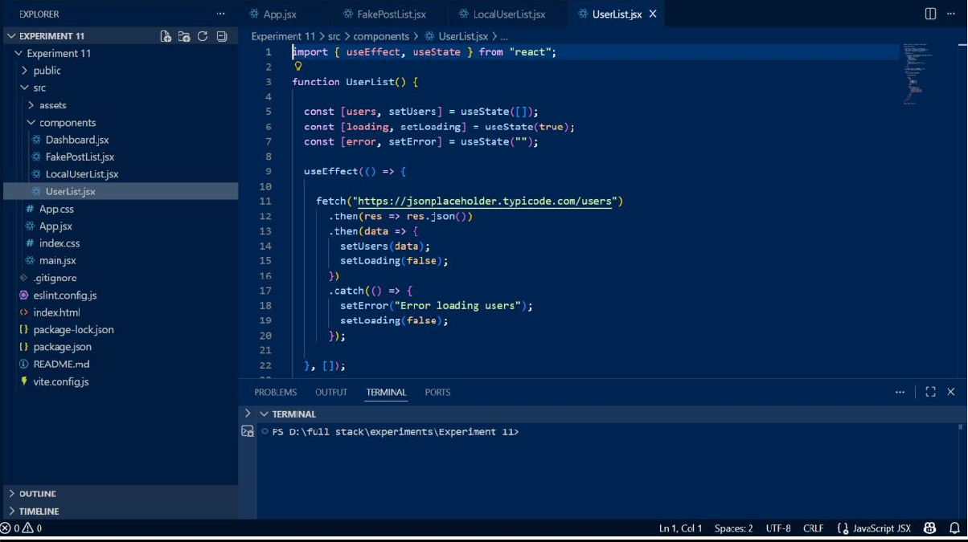
UsersList.jsx

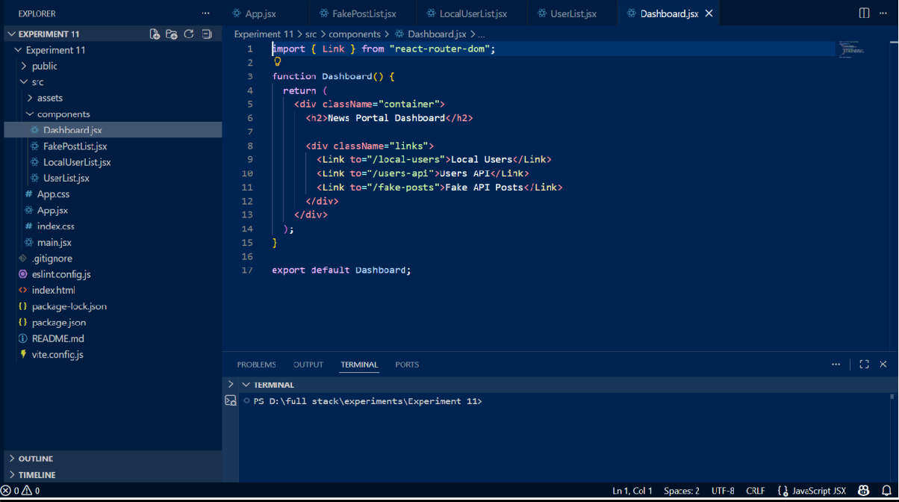
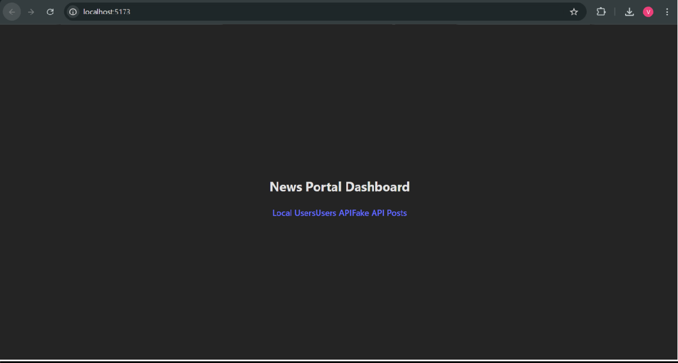
Output :

Github Repo Output:
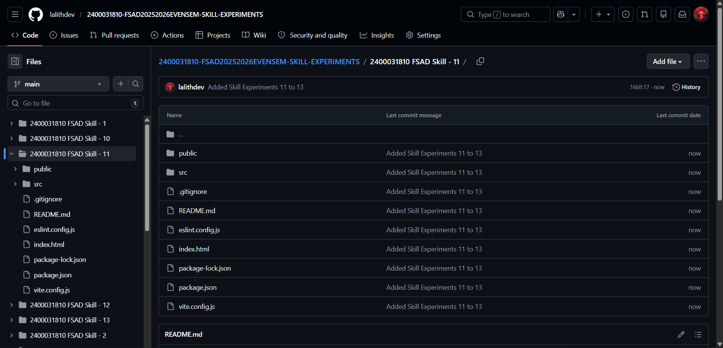

Github Repositoy Link: lalithdev/FSAD-Skill-Experriment-11

